Tenis Nike Book 2 The Phoenix Hombre
$3,799.00
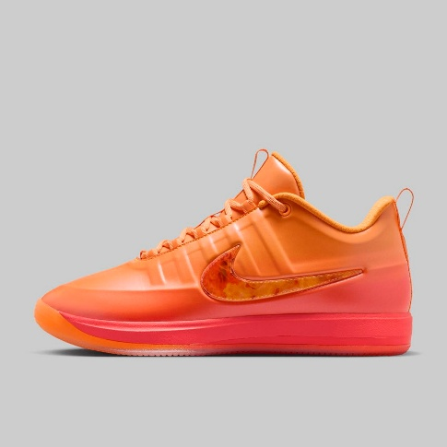
Tenis Nike Jordan Heir Series 2 Hombre
$2,799.00
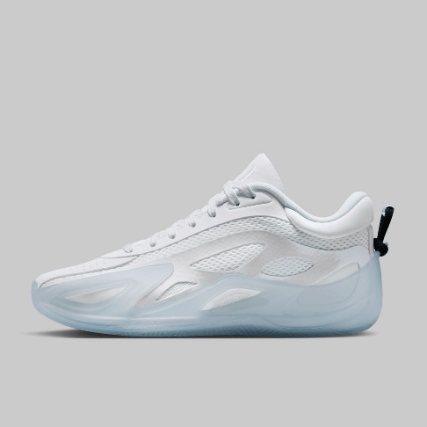
Tenis Nike LeBron XXIII Hombre
$4,699.00
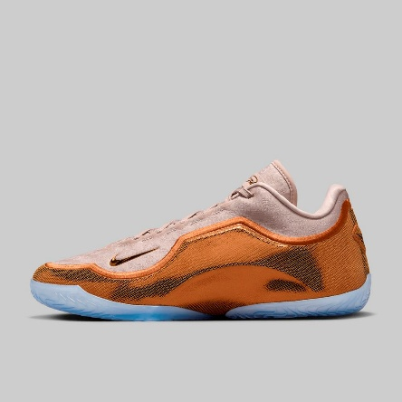
Tenis Reebok Angel Reese 1 Hombre
$3,299.00
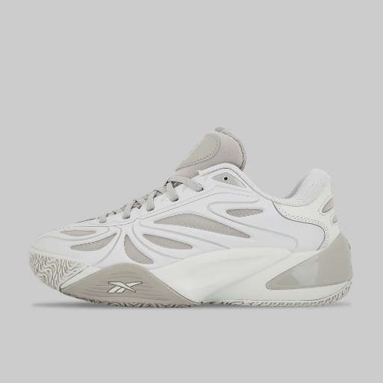
Tenis Nike Jordan Max Aura 7 Hombre
$3,099.00
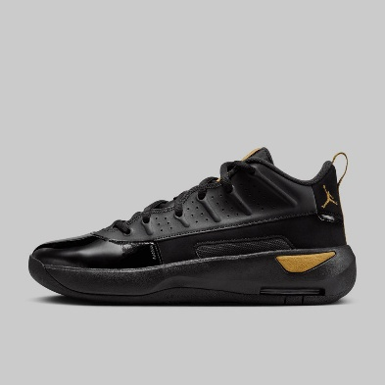
Tenis Puma MB.05 LaMelo Ball Crowd Surf Hombre
$3,499.00
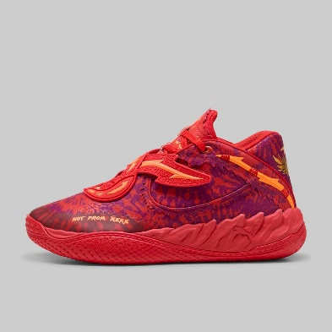

Tenis Nike Jordan Max Aura 7 Hombre
$3,099.00
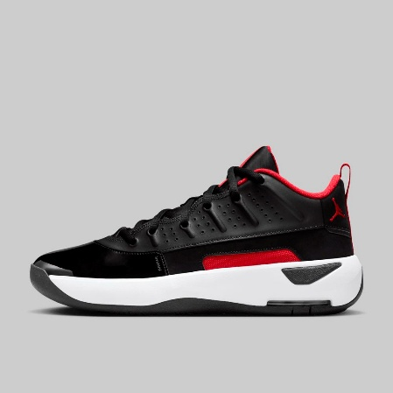
Tenis Nike Book 2 Hombre
$3,399.00
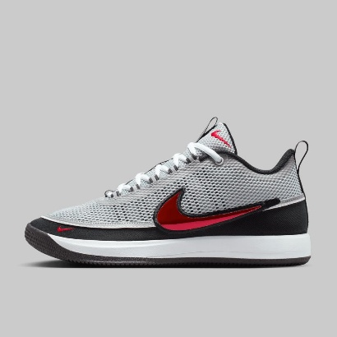
Tenis Nike Jordan Luka 77 Hombre
$2,299.00
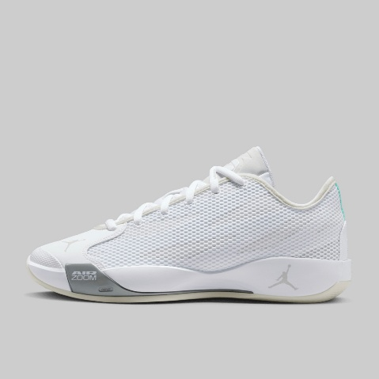

Tenis Nike KD18 International Blue Hombre
$3,999.00
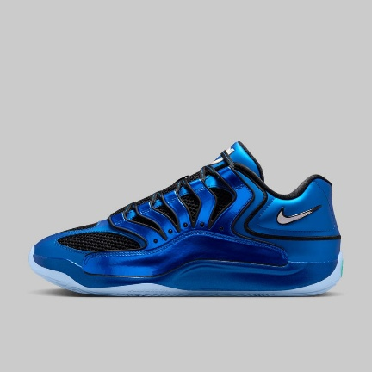
Tenis Under Armour Curry 13 Hombre
$3,999.00
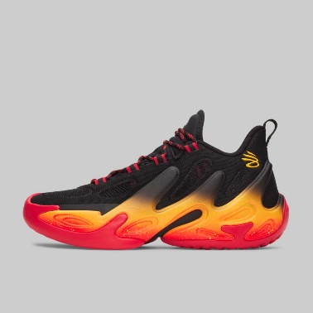
Tenis Nike Air Jordan 40 Hombre
$4,499.00
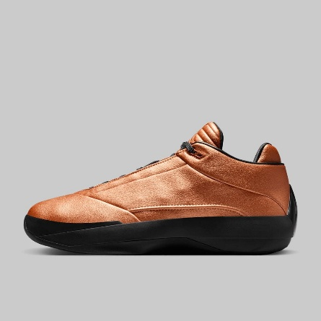

Tenis Nike Jordan Luka 4 Hombre
$3,099.00
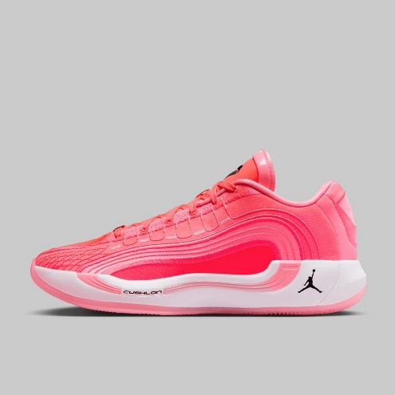
Tenis adidas Harden Volume 9 Hombre
$2,719.20
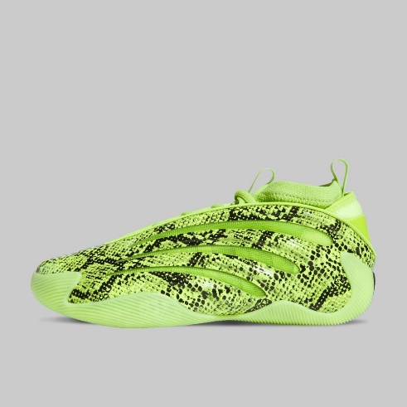
Tenis adidas Harden Volume 10 Hombre
$2,879.20
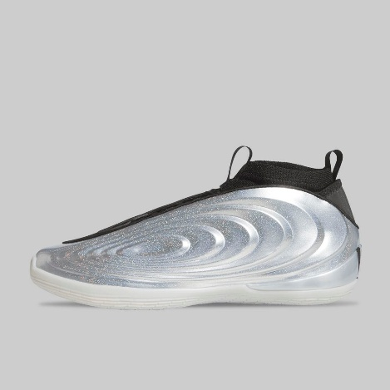
Tenis Nike Giannis Freak 7 Hombre
$2,159.20
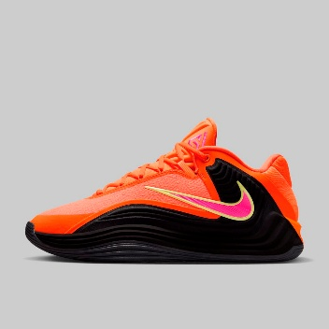
Tenis Nike LeBron XXIII Hombre
$3,759.20
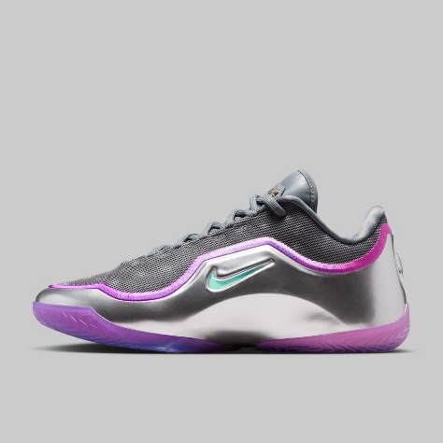
Tenis adidas Anthony Edwards 2 AE2 Hombre
$2,319.20
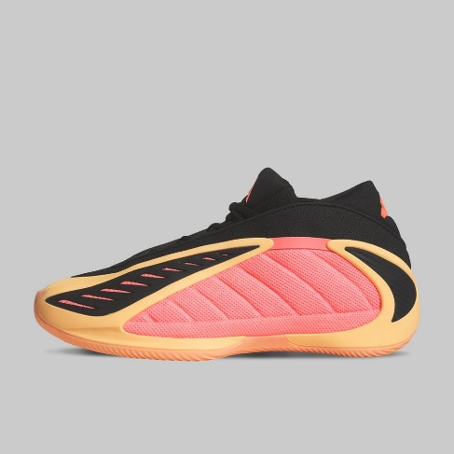

Tenis Nike KD18 Kevin Durant Hombre
$3,039.20
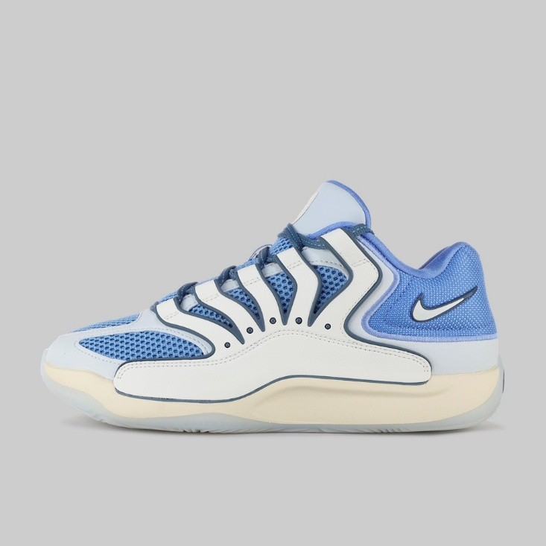
Tenis Onboard Klaxon Hombre
$899.40
